The mayor of Haifa (in Israel) ordered to disconnect WiFi in schools and kindergartens – until examining the safety of WiFi thoroughly

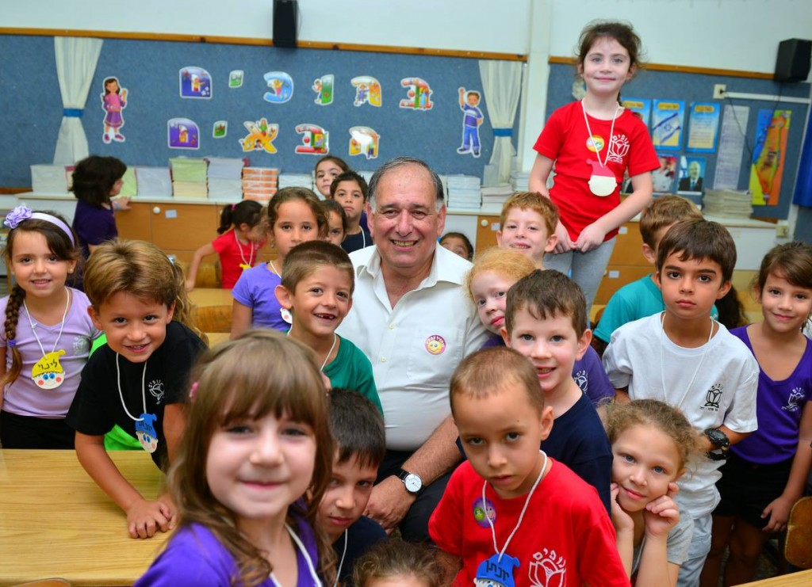

Yona Yahav, the mayor of Haifa with children

Haifa municipality disconnects WiFi in kindergartens and schools in the city
18/4/16

The disconnect is until a thorough examination of WiFi safety is done

Haifa's mayor, Yona Yahav, ordered in coordination with the head of education department, Ilana Truck, to immediately disconnect WiFi in educational system until a thorough examination of the subject. At the same time, Yahav guided to advance the installation of wired safer system.

Yahav: "The education system in Haifa is full of network computers and new, advanced technological systems. However, regarding anything that relates to our children, if there is doubt- there is no doubt. We must take excessive precaution.
As long as the argument on real danger was not refuted, I ordered to disconnect all the devices in kindergartens and in schools. In order not to prevent advanced technology from the children, we will act to activate safe wired system".
In recent years, the internet media has become part of our daily lives. The use of cell phones, smart phones and computers is gaining momentum among a wide range of ages, where children is an especially sensitive population to environmental effects among them exposure to electromagnetic radiation (non ionizing radiation).
Since the publication of the State Comptroller report in December 2014 on the subject
"handling electromagnetic radiation in the education systems by local authorities and private owners", all relevant bodies were recruited to measure radiation in all schools in the country.

Haifa municipality states, that "the education system has advanced computers system of the highest level. They are under control and stand in annual measurements and until today the results were lower than the demand of the existing standard. "

In view of this, and as long as it was not proven that WiFi radiation is dangerous, a discussion has started in the municipality to take precaution and receive answers from the governmental ministries.

Haifa municipality is organizing a conference for the next month, on radiation from cell phones and smart phones, in order to give knowledge to the public on wireless emitting technologies and their effects. The conference will deal with creating a policy for educated use of cell phones in the education system in Haifa. Part of the conference will be dedicated to radiation from Wi-Fi. This week, in coordination with the head of the city's education system, Ilana Truck, Yahav ordered to disconnect immediately the WiFi in kindergartens and schools in Haifa until a thorough examination of the subject is done. These days the education system is preparing to gradually install wired system as an alternative in all education system in the city. These will be installed in the first stage in classrooms where pupils learn for the final exams that force use of computers, so they won't be harmed from the disconnect. The teachers in elementary schools in the city took on themselves to load every evening the studies material from the internet, so that pupils are not exposed and their studies won't be harmed. Dr. Mona Nofi-Naama, head of non ionizing radiation issue, in the Cities Association Haifa Bay for environmental protection: "According to the precautionary principle, it is needed to reduce the exposure to non ionizing radiation as much as possible, among the rest also WiFi, by reducing the use of wireless networks and to prefer in every opportunity wired connection rather than wireless. The standards relate to thermal effect only, while here the subject is health effects that do not relate to heating that are in low levels below the standard, but were not defined.
http://www.local.co.il/haifa/134582/Article/

http://haifahaifa.co.il/%D7%94-wi-fi-%D7%91%D7%92%D7%A0%D7%99-%D7%99%D7%9C%D7%93%D7%99%D7%9D-%D7%95%D7%91%D7%AA%D7%99-%D7%94%D7%A1%D7%A4%D7%A8-%D7%91%D7%97%D7%99%D7%A4%D7%94-%D7%A0/

http://glz.co.il/1087-80579-he/Galatz.aspx

http://www.krayot.com/archives/26653

